NATIONAL INSTITUTE OF BUSINESS MANAGEMENT
HIGHER NATIONAL DIPLOMA IN SOFTWARE ENGINEERING
25.2F
COURSEWORK

Internet of Things

IoT-based Lake Water Safety Monitoring
SUBMITTED BY

R.K.P.M RAJAPAKSHA COHNDSE252F - 023
H.S PERERA COHNDSE252F - 027
A.N BANDARA COHNDSE252F - 066
K.I.K ADITHYA COHNDSE252F - 073

Date of Submission: 21/01/2026

Table of Contents
1. Introduction 3
2. Problem Definition 3
2.1. Research Gap 4
3. Proposed Solution 5
4. Methodology 6
4.1. Overall System Design 6
4.2. Block Diagram 8
5. Budget Allocation 9
6. References 10

Introduction
Lakes and reservations are commonly used as neutral places to be engaged in activities such as swimming, sunbathing and leisure viewing. In most situations, individuals often enter the water bodies without any sort of real-time verification of water safety conditions. The temperature, turbidity, pH, and the number of dissolved solids present in the water can impact our health and safety. The traditional method of water quality testing is by manual sampling. Since this process doesn't get carried out frequently and takes a large amount of time to get to the results, it is completely useless in making immediate decisions.
With the advancement in technologies such as the Internet of Things, it is possible to always monitor the environmental situation with inexpensive sensors and cloud solutions. Given that it combines IoT with a visual interface such as heat maps, we can monitor the water safety status in a fashion that is simple to comprehend by the people and authorities. In essence, the project will establish an IoT-based platform that monitors the water safety levels at the lake in real-time and converts the value into a dynamic heat map to indicate the location of the risk areas.

Problem Definition
Regardless of numerous social activities that people hold in lakes, none of them have a real-time monitoring system that enables them to verify whether the water in the lake is safe for consumption. Most individuals use the visual judgment that is not quite reliable and may cause such disorders as skin infections or waterborne diseases. The authorities also find it difficult to locate the high-risk areas within the lakes since they do not have data that is dispersed spatially.

Research Gap
Even with the existing practices and research there are still a lot of problems that need to be addressed,
- [1]Many systems present water quality data in numerical form which introduces a barrier between the public to interpret and does not effectively communicate risk.
- [2]Sensor fusion techniques are not widely adopted, leading to reduced reliability and accuracy in safety assessments.
- [3]There is a lack of real-time alert mechanisms to warn users and authorities when water quality becomes unsafe for consumption.
- [4]Visualization implementations such as risk-based heat maps are rarely integrated into current water monitoring solutions.

Proposed Solution
The proposed solution intends to use the IoT-based Lake Water Safety Monitoring and Risk-based Heat Map Visualization System to fill the gap in availability of real-time and location-specific information related to safety in the popular lakes available for the consumption of the public.
The proposed solution uses a variety of IoT sensor nodes that are situated in various places within a lake to monitor in a continuous manner for the key water safety parameters including pH, turbidity, temperature, total dissolved solids (TDS), and water depth. Every sensor node uses an ESP32 microcontroller and sends real-time data to a Firebase platform on a cloud through wireless connectivity.
The system uses a sensor fusion technique to measure the conditions in a lake accurately using a combination of measurements of more than one parameter in a single safety index. The alert logic triggers thresholds based on the unsafe conditions during the consumption and an alert is raised when the safety limits are met. The gathered data is spatially tagged with the help of GPS coordinates, which allows it to be processed into an interactive risk heat map in a web or mobile application. Heat maps visually indicate safe and unsafe areas in the lake based on color gradient so that the population and government can clearly know the water safety status by just having a look at the heat map. Additionally, each location contains a digital screen that displays the water safety status for the convenience with a real time alert system.
The suggested solution could have a positive impact on the safety of the population, promote informed decision-making, and provide a scalable and cost-effective solution to control the unsafe conditions in lakes with the use of real-time monitoring and alerting systems with user-friendly visualization.

Methodology

Overall System Design
The proposed system is designed as an Internet of Things based real-time water safety monitoring system for lakes that are open to public consumption. The system follows a layered architecture consisting of the sensing layer, communication layer, cloud processing layer, and application layer. This design enables continuous data gathering, data transmission, intelligent safety evaluation, and representative visualization for both the public and authorities’ usage.
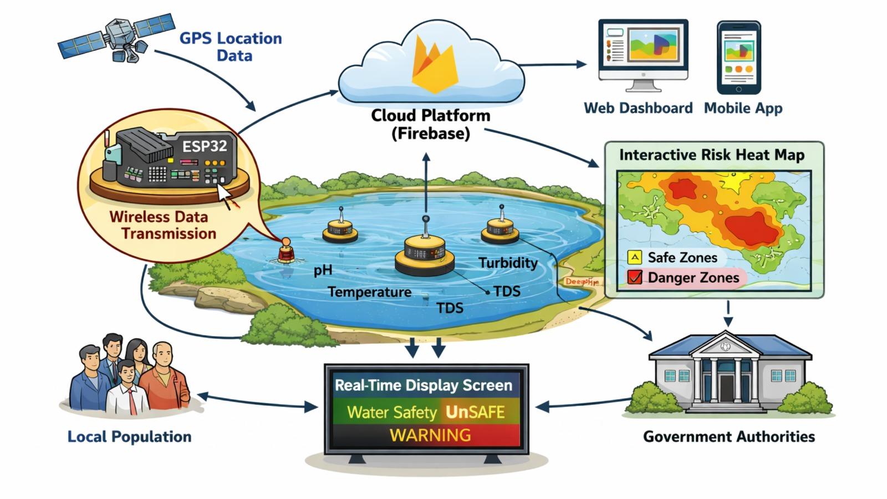

Within the sensing layer, multiple environmental sensors are deployed at different locations with highest public use to measure important water quality parameters such as temperature, pH level, turbidity, and total dissolved solids (TDS). These sensors are connected to a microcontroller unit, such as the ESP32, which is responsible for sensor data gathering, basic validation, and timestamping [5].
The communication layer used to provide wireless transmission of the gathered sensor data to the backend services using Wi-Fi connectivity. The ESP32 periodically uploads the data to a cloud backend.
The cloud processing layer is responsible for data storage, processing, and management through a Firebase-based backend. Sensor fusion techniques are applied to combine multiple sensor readings into a single assessment which helps to improve the accuracy and reliability of the system.
The application layer provides user interaction capabilities and visualization. The water safety data is that gathered and processed gets presented through a web-based dashboard that displays real-time sensor readings using a dynamic heat map. High-risk areas that get identified by using the processed data get highlighted in the heat map to allow quick representation.
Overall, the proposed system perform real-time sensing, cloud-based intelligence, and intuitive visualization to improve informed decision-making and enhance public safety in water bodies.

Block Diagram
  - 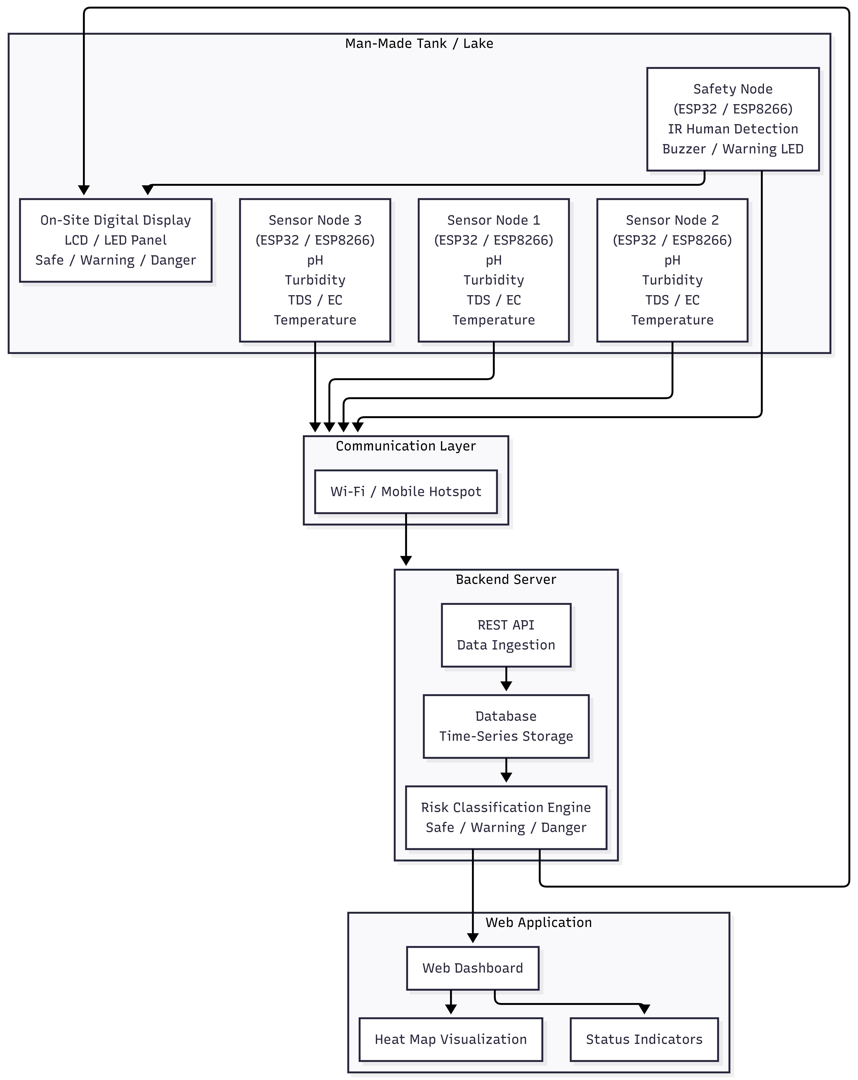

Budget Allocation
The budget is allocated mainly for sensors, microcontrollers, power components and lcd display which are required for monitoring the water conditions of the lake. Some extra is also in there to make it waterproof and to install it so that it can withstand going out and into the elements and cloud services are ensuring that costs are kept to practically nothing.
Components | Quantity | Purpose | Price
ESP32 | 2 | Main processing unit for sensor data collection and Wi-Fi communication | LKR 800–1,680
pH_Sensor Module | 1 | Measure acidity/alkalinity of lake water | LKR 3,500
Turbidity Sensor | 1 | Measure water clarity and detect pollution levels | LKR 2,400
Waterproof Ultrasonic Sensor (JSN-SR04T) | 1 | Measure lake water depth | LKR 2,800
GPS Module (NEO-6M) | 1 | Capture location coordinates for heat map visualization | LKR 3,500
Rechargeable Battery Pack | 2 | Power supply for IoT sensor nodes | LKR 2,000- 2,500
Voltage Regulator & Power Module | 2 | Stable power distribution to sensors | LKR 800 – 1,600
Connecting Wires & Breadboard | 1 | Hardware connections and prototyping | LKR 1,100

References

[1] | M. A. Islam, S. C. Roy, M. F. U. Utsho, L. Naznin, R. Sarkar and R. R. Sarkar, "An IoT-enabled intelligent water quality monitoring system for tourist safety using machine learning," Discover Electronics, vol. 2, p. 10187, 2025.
[2] | X. N. X. C. X. L. Sibo Xia, "Data fusion based wireless temperature monitoring system applied to intelligent greenhouse," Computers and Electronics in Agriculture, vol. 192, 2022.
[3] | S. G. M. T. A. H. A. A. A. I. Y. Y. A. S. S. A. B. I. B. B. Z. A. R. I. Che Zalina Zulkifli, "IoT-Based Water Monitoring Systems: A Systematic Review," Water, vol. 14(22), 2022.
[4] | Y. N. D. a. R. R. Kulkarni, "Utilizing Remote Sensing and GIS for Water Quality Monitoring," International Journal of Water Resources Engineering, vol. 10, no. 1, p. 45–51, 2024.
[5] | S. G. and S. Gouthami, "Internet of things enabled real time water quality monitoring system," Smart Water, vol. 2, no. 1, 2016.

